TS.R

Administrator

Wed May 27 11:30:03 2015

library(Metrics)  
library(data.table)   
library(ggplot2)  
setwd("E:/Dropbox/kaggle/West Nile Virus Prediction")  
#setwd("C:/Users/tshao/Dropbox/kaggle/West Nile Virus Prediction")  
x <- fread("data/train11.csv")  
#test <- fread("data/test5.csv")  
  
train<-x[order(x$Block,x$Date), ]  
  
if(1==0){  
ts10=ts(train[train$Block==10,]$NumMosquitos, start = 2007, freq = 200)  
plot(ts10)  
train[train$Block==10]$Date  
}  
  
train$Date = as.Date(train$Date, "%Y-%m-%d")  
ts=list()  
for (i in unique(train$Block)){  
 ts[[i]]=train[train$Block==i,]  
}  
  
unique(train$Block)

## [1] 10 11 12 13 14 15 17 18 20 21 22 24 25 27 28 29 30 33 34 35 36 37 38  
## [24] 39 40 41 42 43 45 46 47 48 49 50 51 52 53 55 58 60 61 62 63 64 65 66  
## [47] 67 68 70 71 72 73 75 77 79 80 81 82 89 90 91 93 96 98

ggplot(ts[[10]], aes(Date, NumMosquitos)) + geom_line() + xlab("") +ylab("NumMosquitos")+ ggtitle("Block10")

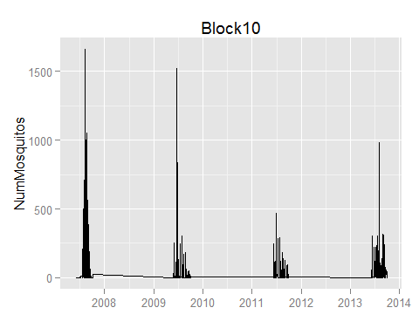

ggplot(ts[[98]], aes(Date, NumMosquitos)) + geom_line() + xlab("") +ylab("NumMosquitos")+ ggtitle("Block98")

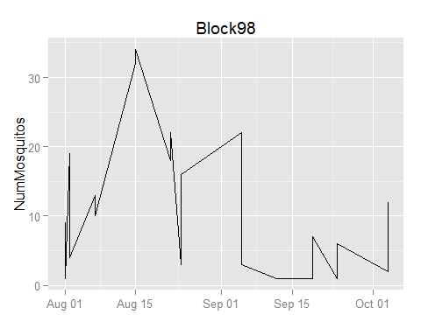

ggplot(ts[[50]], aes(Date, NumMosquitos)) + geom_line() + xlab("") +ylab("NumMosquitos")+ ggtitle("Block50")

